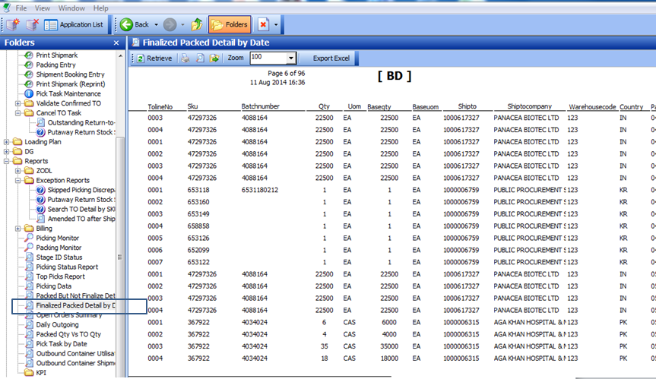

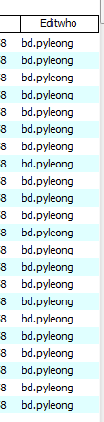**WMS CHANGES:**

Added new report field:

Packed By , PackedDate , Pack lineno, Package ID

